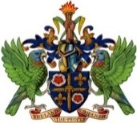

GOVERNMENT OF SAINT LUCIA
OFFICE OF THE PRIME MINISTER

PUBLIC NOTICE

EARLY CLOSURE OF OFFICE

Please be informed that the Office of the Prime Minister and its affiliate agencies will be closed on Friday, June 28, 2024 from 10:30 a.m. to facilitate a staff activity.

The Office of the Prime Minister and its affiliate agencies will resume normal operations on Monday, July 1, 2024.

For our main office, kindly note that all incoming correspondence should be dropped off at the security desk located on the Ground Floor of the
Greaham Louisy Administrative Building.

We do apologize for any inconvenience that this early closure may cause.

By Management

