# saint lucia coat of arms

**Ministry of Education, Sustainable Development, Innovation, Science,**

**Technology and Vocational Training**

## PRESS RELEASE

**2025 OAS-IKLOX EDUCATIONAL OPPORTUNITIES FOR**

**SHORT-TERM POST-GRADUATE COURSES**

The Organisation of American States (OAS) and Integral Solutions for Training and Structure Management are offering sponsorship of 100% of the cost of premium subscription plan of STRUCTURALIA’s online course platform IKLOX.

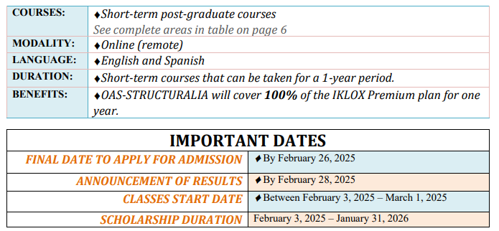

The OAS-IKLOX Scholarship Programme offers a subscription for one year to the Premium Plan of the IKLOX platform, which includes more than 100 English courses subjects in the following areas described below:

* Water (engineering, infrastructure, management, etc.);
* Industry;
* Architecture, buildings, and urban development;
* Civil engineering and structures;
* Big Data;
* Environment;
* Railways (Design, construction, exploitation, maintenance);
* Quality regulations, compliance, and risk prevention;
* Finances;
* New technologies;
* Electric power generation and transport (distribution)
* Smart cities and smart infrastructures
* Management
* Software Project; and
* Project and contract management

Interested applicantscan visit <https://bit.ly/eng_schol> to familiarize themselves with programme details and the requirements for application.

For queries about this offer, please send emails to <https://becasoea.structuralia.com/> and for further guidance on the application process, please contact [juanantonio_cuartero@structuralia.com](mailto:juanantonio_cuartero@structuralia.com) or [manuel.tourne@structuralia.com](mailto:manuel.tourne@structuralia.com).

**PLEASE NOTE**

1. These scholarships are full, so they are free for the Scholars.
2. The scholars will be responsible for the coverage of any expense not covered (for example, certificate print, graduation services, document legalization, etc.)
3. Neither OAS nor Structuralia take any responsibility for the acceptance or refusal of the educational entity’s certificates, within the scholarship recipient’s country of origin. If you would like to know how to legalize, certify, or validate the Structuralia certificate in your country, we recommend you ask for information in your country’s Ministry of Education or the corresponding Public Entity.

**Deadline for submission of application is February 26, 2025.**

***… End of Press Release******…***

**January 22, 2025**

/*bm*